Home Care Plan
(do exercises AT LEAST 3X/WEEK)
Name:

TFL......3x 30 seconds
Sit on edge of chair, cross leg and pull knee to chest. Or you can stand while bracing yourself against a wall and keep the back leg striaght and brush your hip either towards or away from the wall. (Should feel the stretch over the hip).
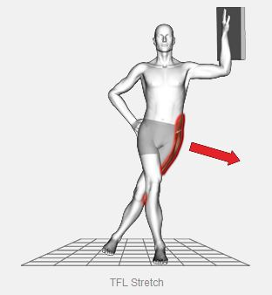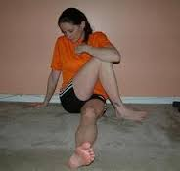
Quads....3x30 seconds
Find an object to stabilize yourself and stand with both legs straight and grab one foot and pull the heel to your butt. Keep both your knees straight down and have your hips forward. You should feel the stretch all on the front of your leg.
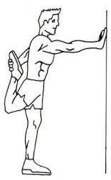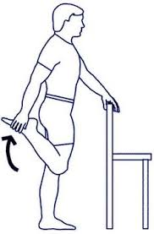

Psoas....3x30 seconds
Kneel down onto one knee and keep other knee straightened out with the leg behind the body (lunge position). You can also bring foot up onto a chair/bench and lunge forward keeping pelvis straight.
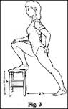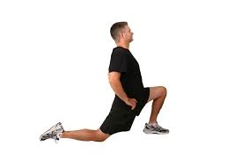
Piriformis....3x30 seconds
Sit on edge of chair, cross leg and lean over, leading with the chest. Pressing down on the knee may increase the stretch. (Should feel stretch around rear of hip).
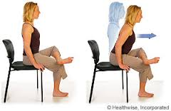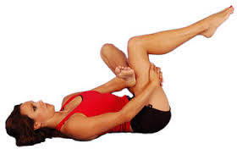
Hamstrings...3x30 seconds
Lay on your back and use a towel, belt or band to loop under the arch of your foot. Keep your leg straight and start lifting it upward until a stretch is felt on the back of the thigh. You can also sit in a chair with a table in front that is even height from the chair and extend one knee out to rest on the table. (You will feel the strech in the back of the leg).
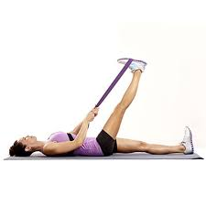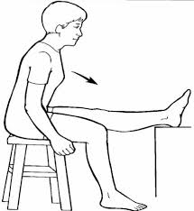

Pecs.....3x30 seconds
Go to a corner of the wall, place your arm and elbow at 90 degrees and place directly against the wall. Take a step forward with the leg that is closest to the wall. (You will feel the stretch across your chest).
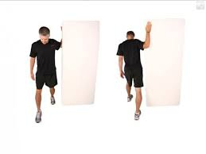
6 Way Neck Stretches.....30 seconds each
-Have chin to chest and to a side at 45 degree angle (Do both sides)
-Bring ear to shoulder. DO NOT SHRUG (Do both sides)
-Bring head back at 45 degree angle (Do both sides)

STRENGTHENING EXERCISES

Neck Drawers...3x10 (To correct Forward Head Posture)
Find a flat surface and lay flat on back(Bend knees if it takes pressure off low back). Press head straight back into the flat surfact for 2-3 seconds then relax. Press straight back with head.

Back Pinches....3x10 (To strengthen rhomboids/lower traps)
While sitting or standing, squeeze shoulder blades together WITHOUT shrugging shoulders. Hold 2-3 seconds then relax.
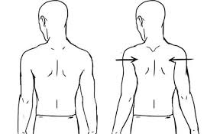

Pelvic Tilt.....2 minutes (To strengthen the lower core muscles)
Lay flat on back with knees bent. Tighten abdominal muscles and draw your pelvis down as you flatten your lower back. DO NOT PUSH WITH LEGS.
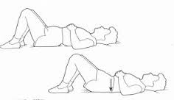

Butterfly.....3x10 (To strengthen the gluteus medius)
Lay on side with upper half of the body relaxed. Have knees straight below torso and bend then to 90 degrees. Squeeze gluteal muscles and keeping both ankles together, raise top knee up then bring back down.
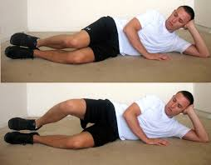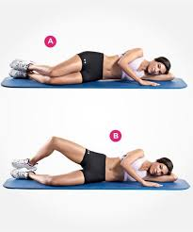
Side Leg Lifts....3x10 (To strengthen the gluteus medius)
Lay on side with upper half of body relaxed and have legs straight below torso. Point the toe on the top leg down towards the floor and bend the bottom knee to 90 degrees. Start exercise by squeezing gluteal muscles, bring top leg up and back at a 45 degree angle.
